**Words not occurred:**

khat

anabolic steroids

metanfetamina

drone

amphetamines

cocaína

narco trafficking

ketamine

traficar drogas

meow meow

crystal meth

pregabalin

4-mmc

4-methyl methcathinone

ecstasy

methylamphetamine

narca

el tráfico de drogas

psilocybin

lsd

pwid

narcotics traffickers

el sporífero

drug dealing

mephedrone

dealing drugs

phencyclidine

ghb

m-cat

drug abuse

benzodiazepines

bath salts

psilocyn

nicotine

narco

white magic

narcóticos

buprenorphine

magic mushrooms

substance abuse

opiate

mdma

Plot for each word occurrence [**before** delete duplicate rows].

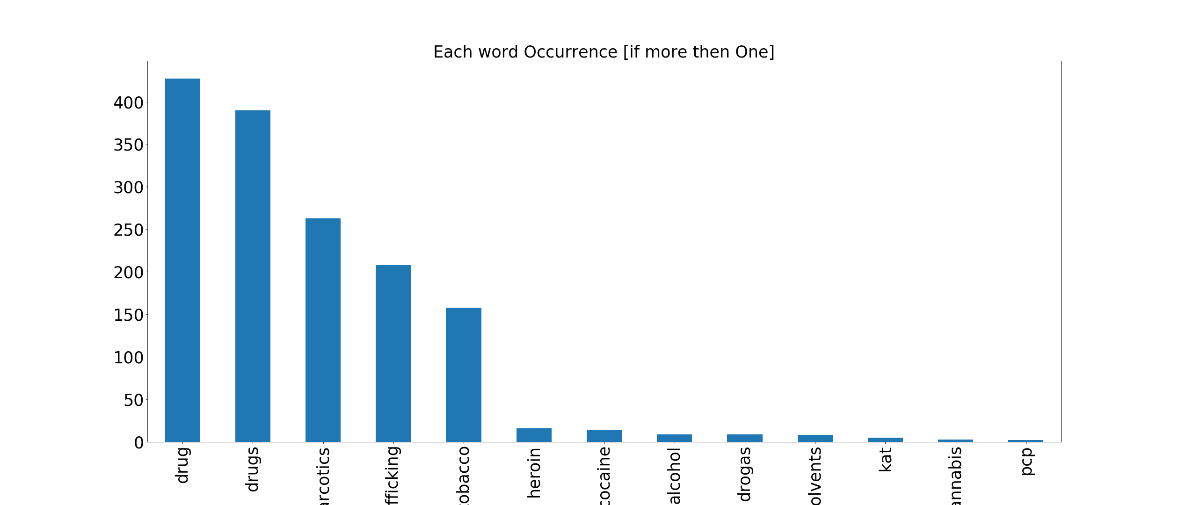

Plot for each word occurrence [**after** delete duplicate rows].

